**Sprint Planning Process:**

**Definition:**

Sprint Planning is a time-boxed Scrum event that kicks off each sprint. It involves the entire Scrum Team (Product Owner, Scrum Master, and Developers) and sets the direction for the upcoming sprint by defining the Sprint Goal, selecting Product Backlog Items (PBIs), and creating a Sprint Backlog.

**Summary :**

Sprint Planning ensures that the team aligns on what will be delivered and how it will be achieved. The Product Owner presents prioritized backlog items, the team discusses feasibility, and developers break down selected items into actionable tasks. The outcome is a shared commitment to a Sprint Goal and a clear plan to deliver it within the sprint timeframe.

**Key Points :**

* **Purpose**: Define what can be delivered and how it will be done.
* **Participants**: Product Owner, Scrum Master, Development Team.
* **Inputs**: Product Backlog, team capacity, past sprint insights.
* **Outputs**: Sprint Goal, Sprint Backlog, task breakdown.
* **Timebox**: Max 8 hours for a 1-month sprint (scaled down for shorter sprints).
* **Focus Areas**:
  + *Why* is this sprint valuable? (Sprint Goal)
  + *What* can be done? (Backlog selection)
  + *How* will it be done? (Task planning)
* **Collaboration**: Encourages shared understanding and ownership.
* **Adaptability**: Plans are flexible and evolve during the sprint.
* **Success Factor**: A well-groomed backlog and clear Sprint Goal.
* 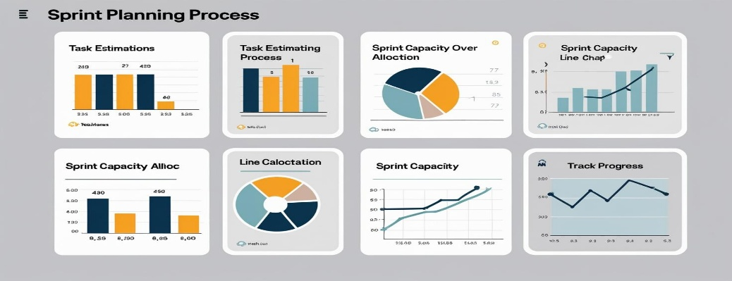

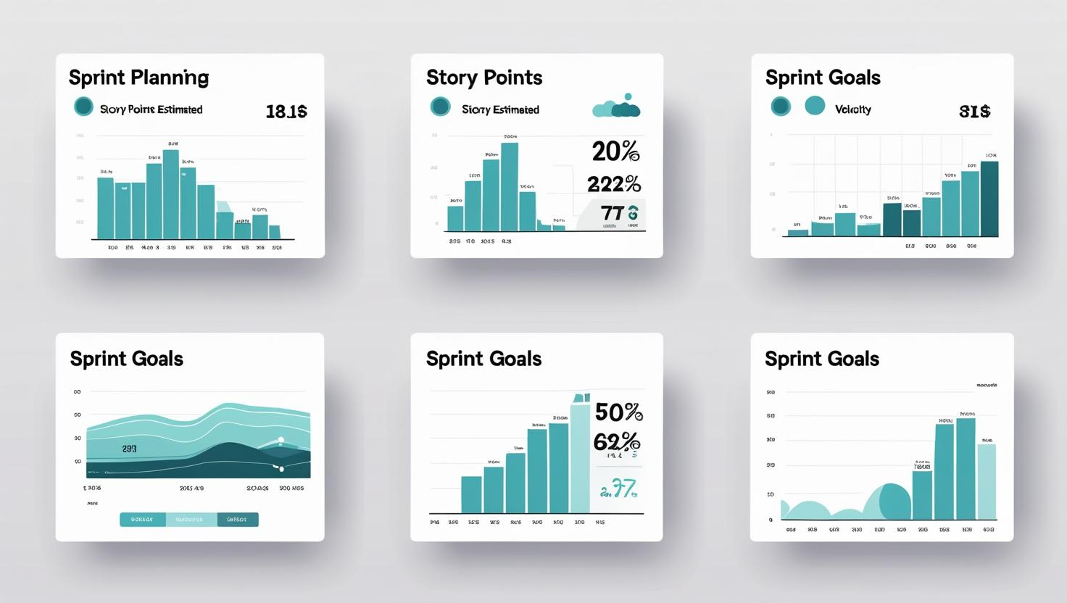

**Comprehensive Summary: Story Points in Agile:**

**Story Points** are a fundamental unit of effort estimation in Agile frameworks, especially **Scrum**. They allow development teams to assess the relative effort required to implement a user story by factoring in **complexity**, **volume of work**, and **uncertainty**, rather than estimating time in hours. This abstraction from time fosters better predictability, consistency, and collaboration in planning software delivery.

Unlike traditional project estimation techniques that rely heavily on time (which can vary widely depending on who's doing the work), story points encourage teams to compare tasks relatively—“Is this story twice as hard as that one?”—rather than asking “How long will it take?”

The power of story points lies in their ability to create a shared language for effort estimation, reduce emotional bias around deadlines, and support better sprint planning through **velocity tracking**—the number of story points completed per sprint.

Estimation is typically done using collaborative techniques like **Planning Poker**, where team members discuss each story, share perspectives, and converge on an agreed point value. The most common scale used is the **Fibonacci sequence** (1, 2, 3, 5, 8, 13…), as it encourages more decisive estimation and reflects the growing uncertainty with larger stories.

A **Story** is a small task . It is part of an **Epic**.

1. Very Easy task
2. Easy task
3. Moderate task
4. Difficult task

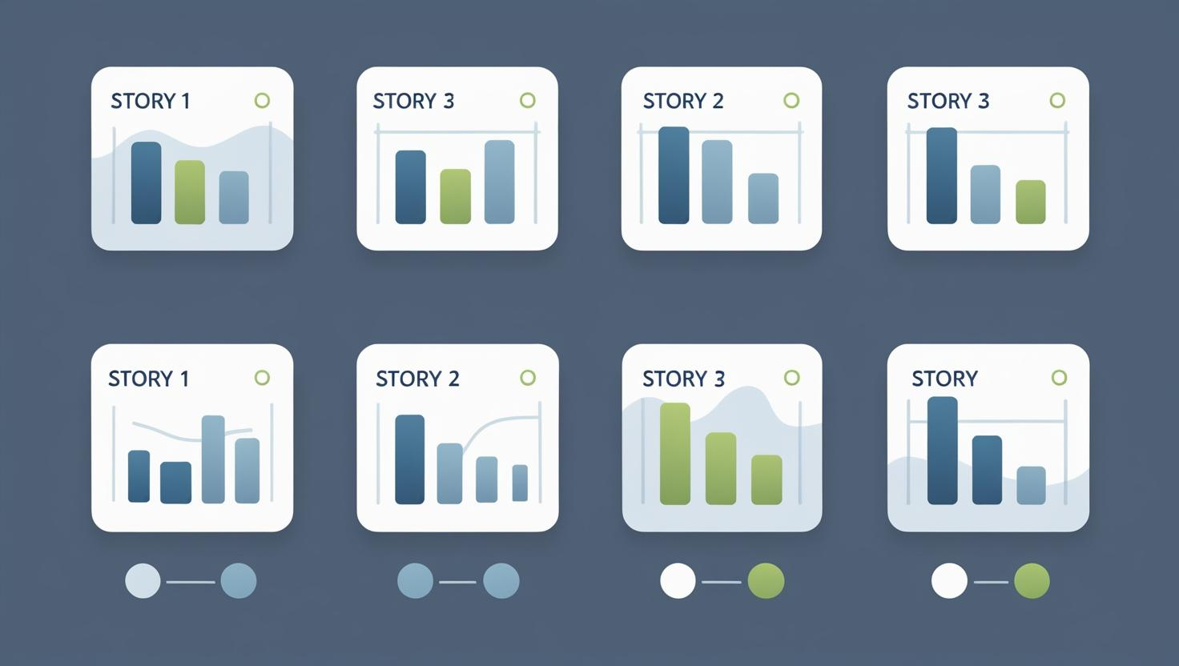

**Sprint 1: (5 Days)**

Data Collection

Collection of Data 2

Loading Data **1**

Data Preprocessing

Handling Missing Values **3**

Handling Categorical values 2

**Sprint 2 (5 Days)**

Model Building

Model Building **5**

Testing Model **3**

Deployment

Working HTML Pages **3**

Flask deployment **5**

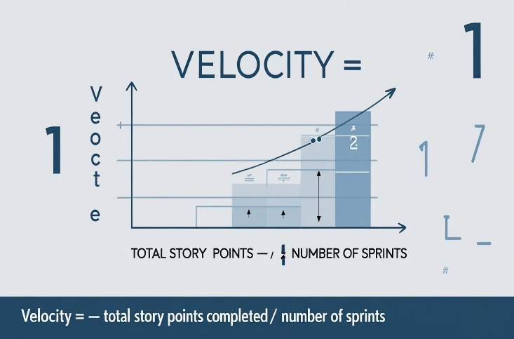

**Total Story Points**

Sprint 1 = 8

Sprint 2 = 16

Velocity= Total Story Points Completed​/ Number of Sprints

Total story Points= 16+8 =24

No of Sprints= 2

**Velocity** = (16+8)/2= 24/2

12 (Story Points per Sprint)

**Your team’s velocity is 12 Story Points per Sprint.**